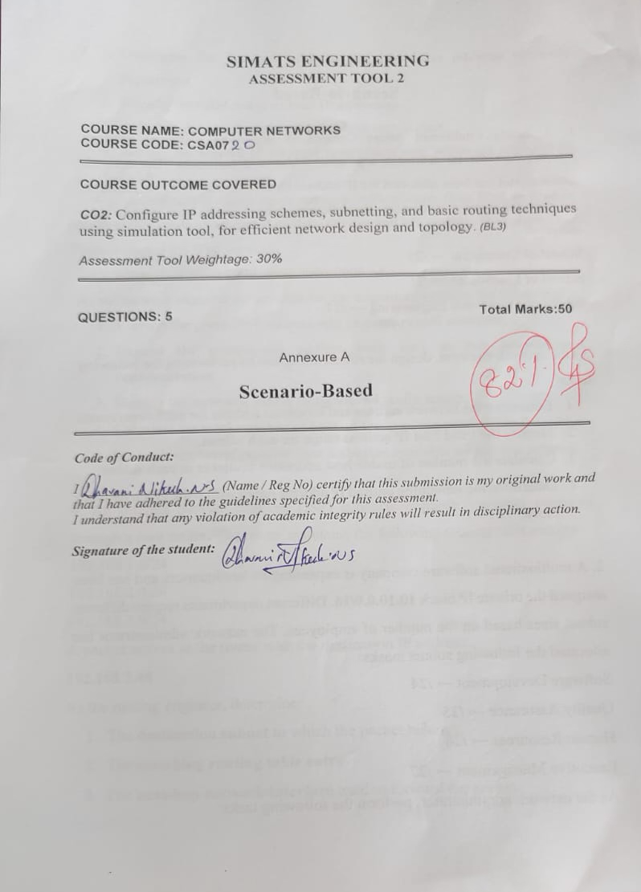

Annexure A

Scenario-Based

1. A newly established Smart Campus is deploying a secure network infrastructure for its academic and administrative departments. The network administrator has been allocated the IP address block 192.168.100.0/24. Based on the expected number of devices, the following subnet masks have already been assigned:
School of Computing → /25
School of Electronics → /26
School of Mechanical Engineering → /27

As the network engineer, design the subnet allocation by performing the following tasks:
- Determine the network address and broadcast address for each department.
- Identify the valid host IP address range for each subnet.
- Calculate the number of usable host addresses available in each subnet.
- Determine the remaining unused IP address range within the given network block.
ANSWER:
1. Smart Campus Network Subnet Allocation
Given Network Block: 192.168.100.0/24
A /24 network contains 2^(32-24) = 2^8 = 256 total addresses (Range: 192.168.100.0 – 192.168.100.255).
Sequential allocation is performed for the three departments to avoid overlap.
A. School of Computing
• Host bits: 32 - 25 = 7 bits
• Total Addresses: 2^7 = 128 addresses
• Usable Host Addresses: 128 - 2 = 126 usable hosts
• Network Address: 192.168.100.0
• Broadcast Address: 192.168.100.127
• Valid Host Range: 192.168.100.1 – 192.168.100.126
Parameter | IP Address / Value
Network Address | 192.168.100.0
First Host Address | 192.168.100.1
Last Host Address | 192.168.100.126
Broadcast Address | 192.168.100.127
Usable Hosts | 126

B. School of Electronics
Next available address begins at .128.
• Host bits: 32 - 26 = 6 bits
• Total Addresses: 2^6 = 64 addresses
• Usable Host Addresses: 64 - 2 = 62 usable hosts
• Network Address: 192.168.100.128
• Broadcast Address: 192.168.100.191
• Valid Host Range: 192.168.100.129 – 192.168.100.190
Parameter | IP Address / Value
Network Address | 192.168.100.128
First Host Address | 192.168.100.129
Last Host Address | 192.168.100.190
Broadcast Address | 192.168.100.191
Usable Hosts | 62

C. School of Mechanical Engineering
Next available address begins at .192.
• Host bits: 32 - 27 = 5 bits
• Total Addresses: 2^5 = 32 addresses
• Usable Host Addresses: 32 - 2 = 30 usable hosts
• Network Address: 192.168.100.192
• Broadcast Address: 192.168.100.223
• Valid Host Range: 192.168.100.193 – 192.168.100.222
Parameter | IP Address / Value
Network Address | 192.168.100.192
First Host Address | 192.168.100.193
Last Host Address | 192.168.100.222
Broadcast Address | 192.168.100.223
Usable Hosts | 30

D. Remaining Unused Address Range
• Unused Range: 192.168.100.224 – 192.168.100.255
• Total Unused Addresses: 256 - 128 - 64 - 32 = 32 addresses
Summary Allocation Table – Question 1
Department | CIDR | Network | Host Range | Broadcast | Usable
Computing | /25 | 192.168.100.0 | .1 – .126 | 192.168.100.127 | 126
Electronics | /26 | 192.168.100.128 | .129 – .190 | 192.168.100.191 | 62
Mechanical | /27 | 192.168.100.192 | .193 – .222 | 192.168.100.223 | 30
Unused | — | 192.168.100.224 | .224 – .255 | 192.168.100.255 | 32 addresses

2. A multinational software company is expanding its headquarters and has been assigned the private IP block 10.10.0.0/16. Different departments require different subnet sizes based on the number of employees. The network administrator has allocated the following subnet masks:
Software Development → /24
Quality Assurance → /25
Human Resources → /26
Executive Management → /27
As the network administrator, perform the following tasks:
- Determine the network address and broadcast address for each department.
- Identify the valid range of host IP addresses.
- Calculate the number of usable hosts in each subnet.
- Identify the unused IP address range remaining within the allocated IP block.
ANSWER:
2. Multinational Software Company Subnetting
Given Network Block: 10.10.0.0/16
A /16 prefix contains 2^(32-16) = 65,536 total IP addresses (Range: 10.10.0.0 – 10.10.255.255).
Subnet Breakdown
A. Software Development (/24):
• Host bits: 8 | Total: 256 | Usable: 254
• Network: 10.10.0.0 | Broadcast: 10.10.0.255 | Range: 10.10.0.1 – 10.10.0.254
B. Quality Assurance (/25):
• Host bits: 7 | Total: 128 | Usable: 126
• Network: 10.10.1.0 | Broadcast: 10.10.1.127 | Range: 10.10.1.1 – 10.10.1.126
C. Human Resources (/26):
• Host bits: 6 | Total: 64 | Usable: 62
• Network: 10.10.1.128 | Broadcast: 10.10.1.191 | Range: 10.10.1.129 – 10.10.1.190
D. Executive Management (/27):
• Host bits: 5 | Total: 32 | Usable: 30
• Network: 10.10.1.192 | Broadcast: 10.10.1.223 | Range: 10.10.1.193 – 10.10.1.222
E. Remaining Unused Address Space:
• Range: 10.10.1.224 – 10.10.255.255 (Provides significant expansion space for future subnets).
Summary Allocation Table – Question 2
Department | CIDR | Network | Host Range | Broadcast | Usable
Software Dev | /24 | 10.10.0.0 | 10.10.0.1 – .254 | 10.10.0.255 | 254
QA | /25 | 10.10.1.0 | 10.10.1.1 – .126 | 10.10.1.127 | 126
HR | /26 | 10.10.1.128 | 10.10.1.129 – .190 | 10.10.1.191 | 62
Executive | /27 | 10.10.1.192 | 10.10.1.193 – .222 | 10.10.1.223 | 30
Unused | — | 10.10.1.224 | 10.10.1.224 – 10.10.255.255 | 10.10.255.255 | 65,056

3.A smart hospital is migrating its network infrastructure from IPv4 to IPv6 to support thousands of connected medical devices and IoT sensors. The hospital has been assigned the IPv6 network:
2001:0db8:abcd:0000:0000:0000:0000:0000/64
As the network engineer responsible for the migration, perform the following:
- Convert the given IPv6 address into its compressed notation.
- Expand the compressed address back into its full hexadecimal representation.
- Identify the network prefix using the /64 prefix length.
- Calculate the total number of host addresses supported within the subnet.
- the total number of possible host addresses available within this network.
ANSWER:
Smart Hospital IPv6 Network
Given IPv6 Address Block: 2001:0db8:abcd:0000:0000:0000:0000:0000/64
IPv6 addresses are 128-bit numbers represented as eight 16-bit hexadecimal blocks.
A. Compressed Notation
1. Remove leading zeros: 2001:db8:abcd:0:0:0:0:0
2. Replace contiguous zero blocks with '::':
Result: 2001:db8:abcd::/64
B. Expanded Notation
Expanding '::' restores the five missing 16-bit zero groups:
Result: 2001:0db8:abcd:0000:0000:0000:0000:0000/64
C. Network Prefix
The prefix length /64 indicates that the first 64 bits form the network component:
Network Prefix: 2001:db8:abcd:0000::/64
D. Number of Host Addresses
- Remaining bits for Interface ID: 128 - 64 = 64 bits.
Total host addresses: 2^64 = 18,446,744,073,709,551,616 addresses

4. An Internet Service Provider (ISP) connects multiple customer networks through a core router. The router maintains the following routing table entries:
192.168.1.0/24
192.168.2.0/24
192.168.3.0/24
A packet arrives at the router with the destination IP address:
192.168.2.45
As the routing engineer, determine:
- The destination subnet to which the packet belongs.
- The matching routing table entry.
- The next-hop network/interface used to forward the packet.
- The default route that should be used if the destination does not match any routing table entry.
ANSWER:

ISP Routing Table Analysis
Destination IP Address: 192.168.2.45
Routing Table Entries: 192.168.1.0/24, 192.168.2.0/24, 192.168.3.0/24
Analysis & Routing Decisions
• Destination Subnet: The IP 192.168.2.45 falls in the range 192.168.2.0 – 192.168.2.255, corresponding to subnet 192.168.2.0/24.
• Matching Entry: The router matches the entry 192.168.2.0/24 in its table.
• Next-Hop / Interface: The table does not specify explicit next-hop IPs or interface names; the packet will be forwarded out of the physical/logical interface bound to 192.168.2.0/24.
• Default Route: If a destination IP does not match any specific route, the router uses the default route: 0.0.0.0/0.
Parameter | Routing Value / Decision
Destination IP | 192.168.2.45
Destination Subnet | 192.168.2.0/24
Matching Route Entry | 192.168.2.0/24
Forwarding Action | Outbound interface associated with 192.168.2.0/24
Default Route Fallback | 0.0.0.0/0

5. A company establishes two office departments connected through a Layer-3 router. The allocated subnet information is as follows:
Administration LAN → 192.168.10.0/26
Finance LAN → 192.168.10.64/26
The router interfaces are configured with:
Administration Gateway → 192.168.10.1
Finance Gateway → 192.168.10.65
As the network administrator, perform the following tasks:
- Determine the network address and broadcast address for each LAN.
- Identify the valid host IP address range.
- Suggest suitable IP addresses for three computers in each LAN.
- Identify the default gateway that hosts in each LAN should use for communication.
ANSWER:
Administration and Finance LAN Setup
Subnet Mask /26: 255.255.255.192 (Block size: 64 addresses, Usable hosts per subnet: 62)
A. Administration LAN (192.168.10.0/26)
• Network Address: 192.168.10.0
• Broadcast Address: 192.168.10.63
• Valid Host Range: 192.168.10.1 – 192.168.10.62
• Default Gateway: 192.168.10.1
Administration LAN Computer Configuration:
Device Name | IP Address | Subnet Mask | Default Gateway
PC1 | 192.168.10.2 | 255.255.255.192 | 192.168.10.1
PC2 | 192.168.10.3 | 255.255.255.192 | 192.168.10.1
PC3 | 192.168.10.4 | 255.255.255.192 | 192.168.10.1

B. Finance LAN (192.168.10.64/26)
• Network Address: 192.168.10.64
• Broadcast Address: 192.168.10.127
• Valid Host Range: 192.168.10.65 – 192.168.10.126
• Default Gateway: 192.168.10.65
Finance LAN Computer Configuration:
Device Name | IP Address | Subnet Mask | Default Gateway
PC1 | 192.168.10.66 | 255.255.255.192 | 192.168.10.65
PC2 | 192.168.10.67 | 255.255.255.192 | 192.168.10.65
PC3 | 192.168.10.68 | 255.255.255.192 | 192.168.10.65

